**Oops**

**C01**

**Course Level Assessment Questions**

**Course Outcome 1 (CO1):**

1. Define a class ‘product’ with data members pcode, pname and price. Create 3 objects of

the class and find the product having the lowest price.

**PROGRAM:**

package product;

import java.util.Scanner;

/**

*

* @author sjcet

*/

public class Product {

int pcode;

String pname;

int price;

public Product(){

Scanner s=new Scanner(System.in);

System.out.println("ENTER THE PRODUCT CODE:");

pcode=s.nextInt();

System.out.println("ENTER THE PRODUCT NAME:");

pname=s.next();

System.out.println("ENTER THE PRICE:");

price=s.nextInt();

}

public void disp()

{

System.out.println("details of the product which has lowest price");

System.out.println("product code is:"+pcode);

System.out.println("product name is:"+pname);

System.out.println("product price is:"+price);

}

public static void main(String[] args) {

Product p1=new Product();

Product p2=new Product();

Product p3=new Product();

if(p1.price<p2.price&&p1.price<p3.price)

p1.disp();

else if(p2.price<p1.price&&p2.price<p3.price)

p2.disp();

else

p3.disp();

}

}

**OUTPUT:**

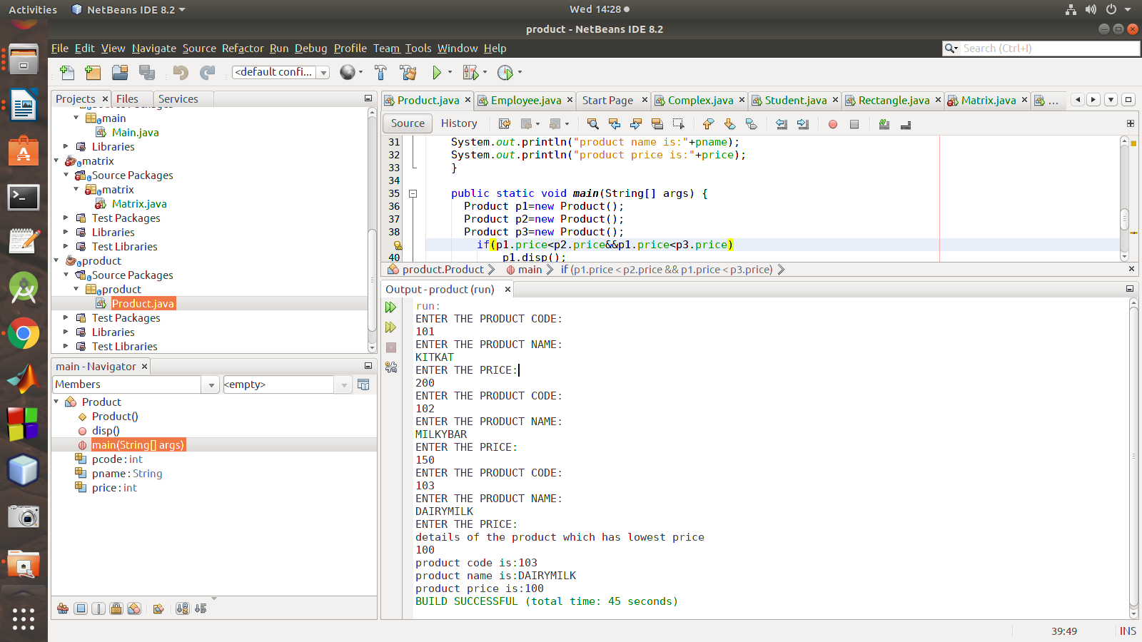

2. Read 2 matrices from the console and perform matrix addition.

**PROGRAM:**

package matrix;

import java.util.Scanner;

public class Matrix {

public static void main(String[] args) {

int i,j,m,n,p,q;

Scanner s=new Scanner(System.in);

System.out.println(" Martrix-1\n-----------");

System.out.println("Enter the no.of rows and coloumn : ");

m=s.nextInt();

n=s.nextInt();

System.out.println(" Martrix-2\n-----------");

System.out.println("Enter the no.of rows and coloumn : ");

p=s.nextInt();

q=s.nextInt();

if(m==p && n==q)

{

int a[][]=new int[m][n];

int b[][]=new int[p][q];

System.out.println("Enter the elments matrix-1");

for(i=0;i<m;i++)

{

for(j=0;j<n;j++)

{

a[i][j]=s.nextInt();

}

}

System.out.println("Enter the elments matrix-2");

for(i=0;i<m;i++)

{

for(j=0;j<n;j++)

{

b[i][j]=s.nextInt();

}

}

System.out.println("\n Matrix-1 \n-----------");

for(i=0;i<m;i++)

{

for(j=0;j<n;j++)

{

System.out.print(a[i][j]+"\t");

}

System.out.println("\n");

}

System.out.println("\n Matrix-2 \n-----------");

for(i=0;i<m;i++)

{

for(j=0;j<n;j++)

{

System.out.print(b[i][j]+"\t");

}

System.out.println("\n");

}

System.out.println("\n Matrix-1 + Matrix-2\n---------------------");

for(i=0;i<m;i++)

{

for(j=0;j<n;j++)

{

System.out.print(a[i][j]+b[i][j]+"\t");

}

System.out.println("\n");

}

}

**OUTPUT:**

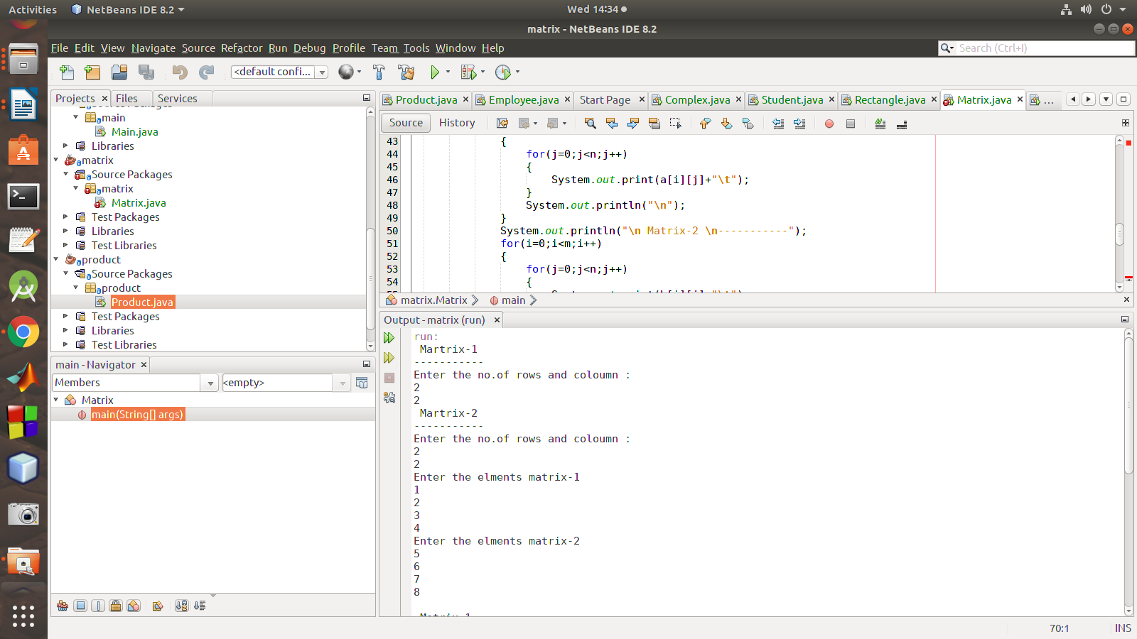

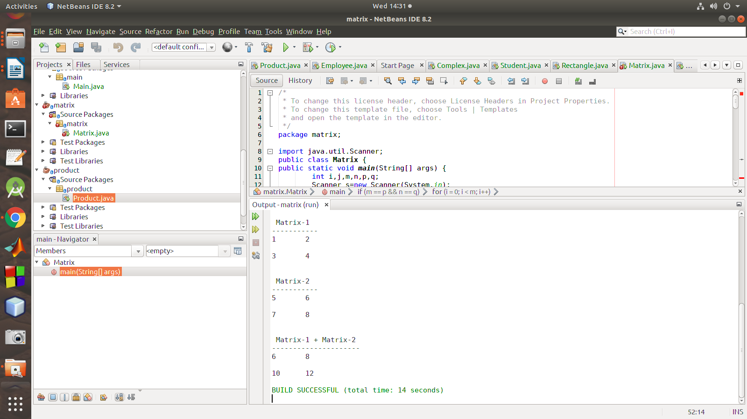

3. Add complex numbers

**PROGRAM:**

package complex;

import java.util.Scanner;

public class Complex {

double real;

double imaginary;

Complex(){}

Complex(double real,double imaginary){

this.real = real;

this.imaginary = imaginary;

}

public static Complex sum(Complex a, Complex b){

Complex ans = new Complex();

ans.real = a.real + b.real;

ans.imaginary = a.imaginary + b.imaginary;

return ans;

}

public static void main(String[] args) {

// TODO code application logic here

Scanner sc = new Scanner(System.in);

Complex num1 = new Complex();

Complex num2 = new Complex();

System.out.println("Enter first complex number: \nreal: ");

num1.real = sc.nextDouble();

System.out.println("\nimaginary: ");

num1.imaginary = sc.nextDouble();

System.out.println("Enter Second complex number: \nreal: ");

num2.real = sc.nextDouble();

System.out.println("\nimaginary: ");

num2.imaginary = sc.nextDouble();

Complex answer = sum(num1,num2);

System.out.println("The addition of two complex numbers is : "+answer.real+" + "+answer.imaginary+"i");

}

}

**OUTPUT:**

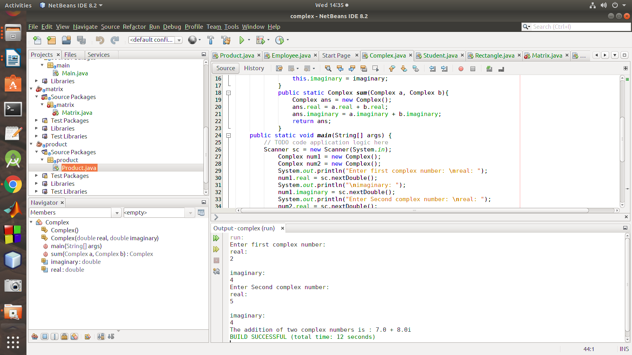

4. Create CPU with attribute price. Create inner class Processor (no. of cores, manufacturer)

and static nested class RAM (memory, manufacturer). Create an object of CPU and print

information of Processor and RAM.

**PROGRAM:**

package main;

class CPU {

double price;

class Processor{

double cores;

String manufacturer;

double getCache(){

return 4.3;

}

}

protected class RAM{

double memory;

String manufacturer;

double getClockSpeed(){

return 5.5;

}

}

}

public class Main {

public static void main(String[] args) {

CPU cpu = new CPU();

CPU.Processor processor = cpu.new Processor();

CPU.RAM ram = cpu.new RAM();

System.out.println("Processor Cache = " + processor.getCache());

System.out.println("Ram Clock speed = " + ram.getClockSpeed());

}

}

**OUTPUT:**

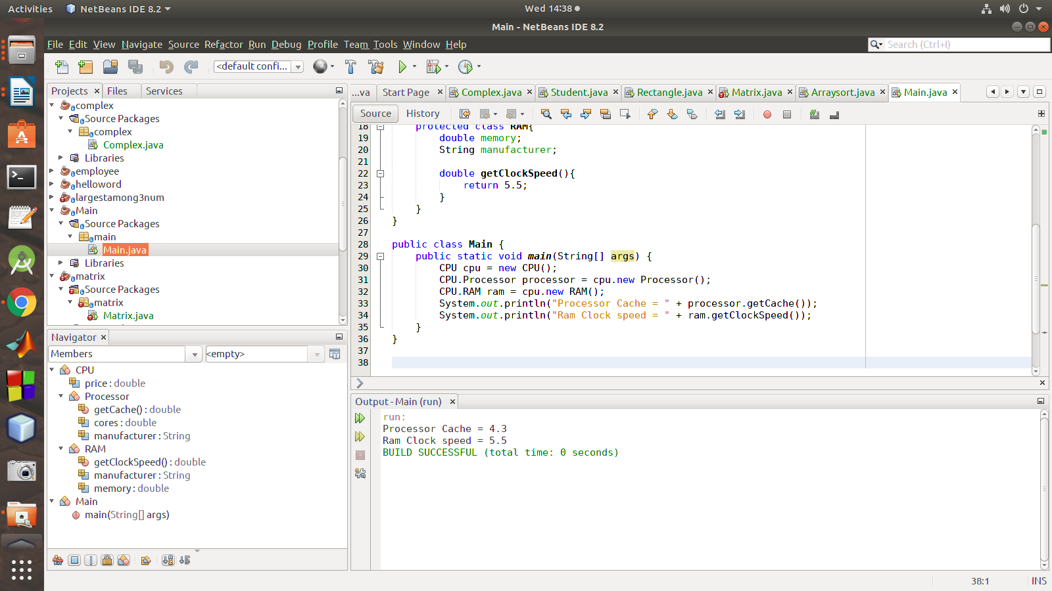

**C02**

**Course Outcome 2 (CO2)**

1. Program to Sort strings.

**PROGRAM:**

package arraysort;

/**

*

* @author sjcet

*/

import java.util.*;

public class Arraysort {

public static void main(String[] args) {

int n;

Scanner s=new Scanner(System.in);

System.out.println("Enter the limit: ");

n=s.nextInt();

String[] ar=new String[n];

System.out.println("Enter the strings:");

for(int i=0;i<n;i++)

{

ar[i]=s.next();

}

System.out.println("\nBefore sorting the Strings are:");

for(int i=0;i<n;i++)

{

System.out.println(ar[i]);

}

String temp;

for(int i=0;i<n;i++)

{

for(int j=i+1;j<n;j++)

{

if (ar[i].compareTo(ar[j]) > 0)

{

temp = ar[i];

ar[i] = ar[j];

ar[j] = temp;

}

}

}

System.out.println("\nAfter sorting the Strings are:");

for(int i=0;i<n;i++)

{

System.out.println(ar[i]);

}

}

}

**OUTPUT:**

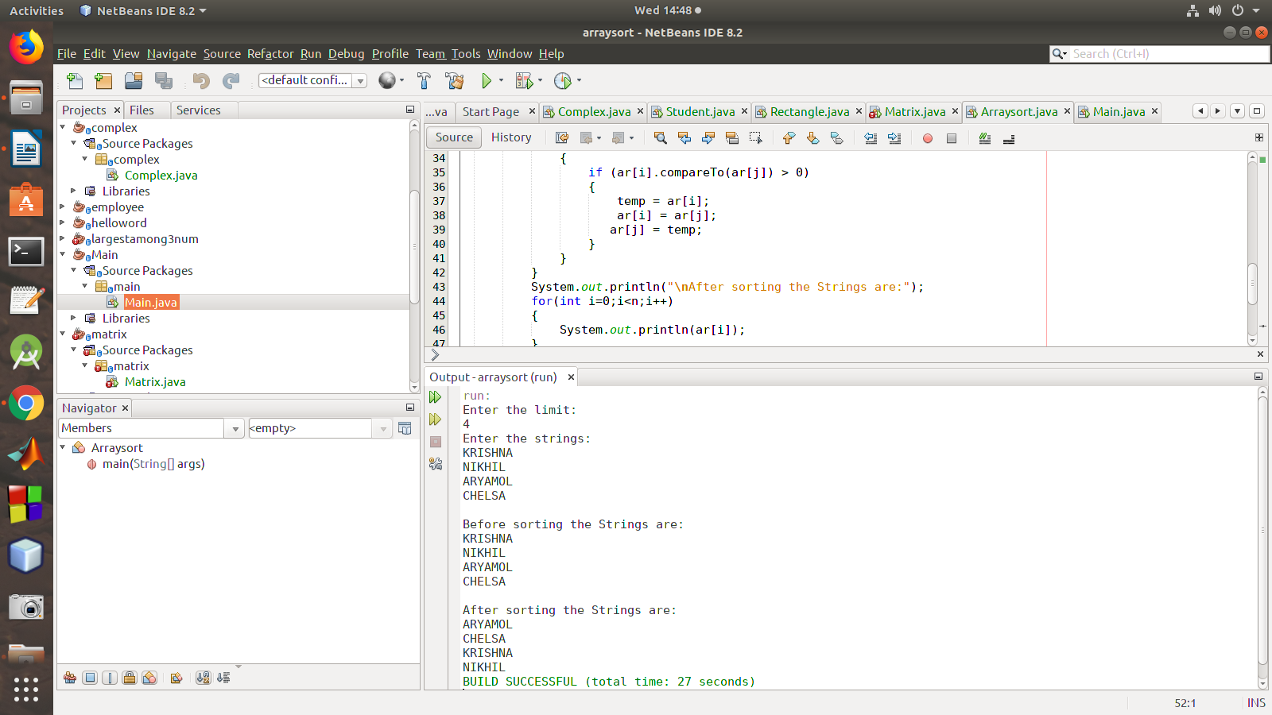

2. Perform string manipulations

**program:**

package stringmanip;

import java.util.Scanner;

public class Stringmanip {

String str1,str2;

Stringmanip(String s1,String s2){

str1=s1;

str2=s2;

}

public void strLen(){

System.out.println("\n The length of string-1 :"+str1.length());

System.out.println("\n The length of string-2 :"+str2.length());

}

public void strConcat(){

System.out.println("\n Concatenated String-1 and String-2:"+(str1.concat(str2)));

}

public void compare(){

System.out.println("\n Compare String-1 and String-2 "+(str1.equals(str2)));

}

public void LowerCase(){

System.out.println("\n lowercase of String-1 "+(str1.toLowerCase()));

}

public void UpperCase(){

System.out.println("\n uppercase of String-1 "+(str2.toUpperCase()));

}

public static void main(String[] args) {

String s1,s2;

Scanner sc =new Scanner(System.in);

System.out.println("Enter the String-1");

s1=sc.nextLine();

System.out.println("Enter the String-2");

s2=sc.nextLine();

Stringmanip s=new Stringmanip(s1,s2);

s.strLen();

s.strConcat();

s.compare();

s.LowerCase();

s.UpperCase();

}

}

**output:**

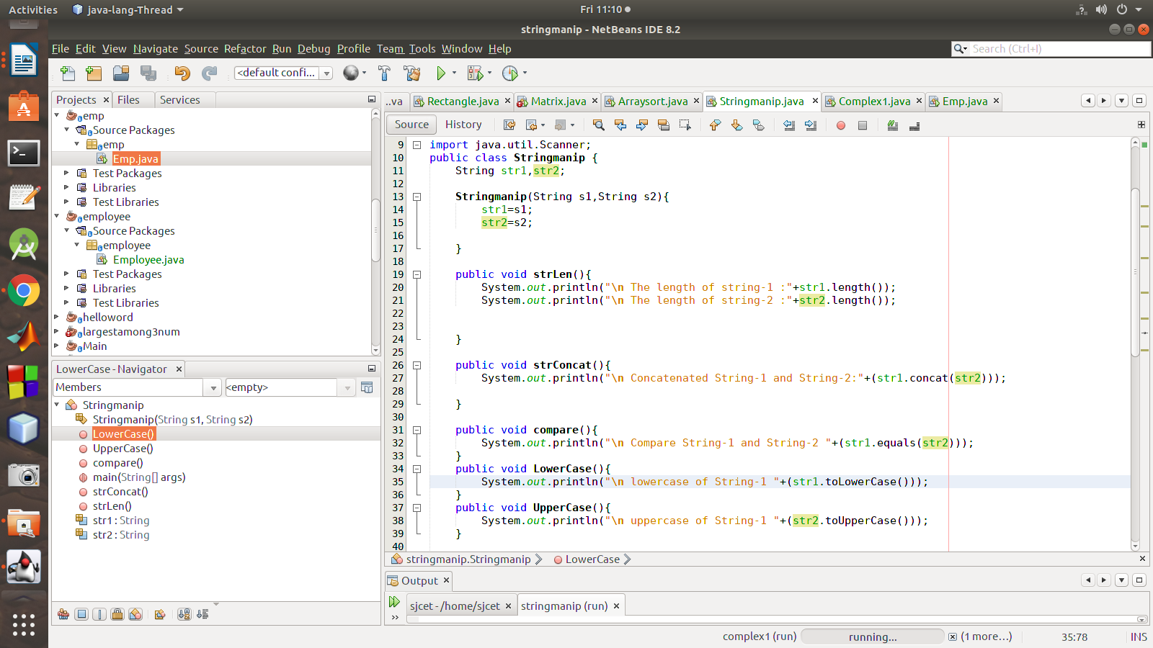

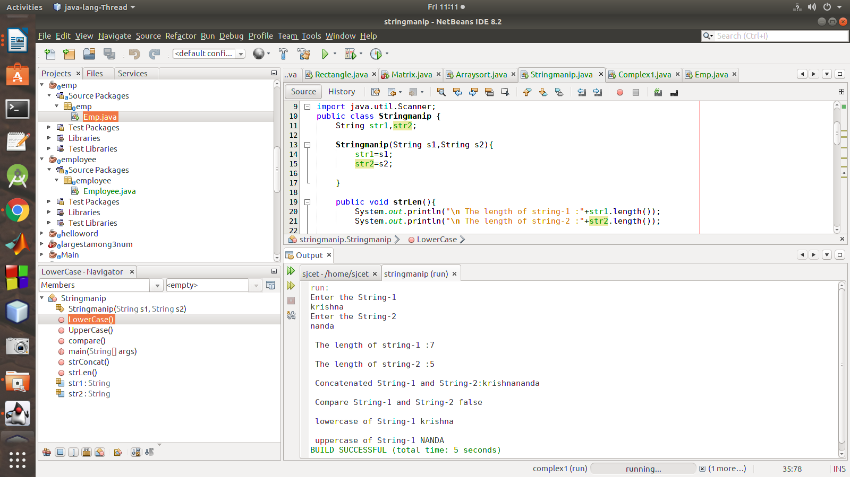

3. Program to create a class for Employee having attributes eNo, eName eSalary. Read n

employ information and Search for an employee given eNo, using the concept of Array of

Objects.

**Program:**

package emp;

import java.util.Scanner;

class Emp

{

int id;

String name;

float salary;

public static void main(String args[])

{

Scanner sc = new Scanner(System.in);

System.out.print("Enter the number of employees");

int n = sc.nextInt();

Emp emp[] = new Emp[n];

for (int i = 0; i < n; i++) {

emp[i] = new Emp();

System.out.println("Enter details of employee " + (i + 1)

);

System.out.print("Enter employee id :");

emp[i].id = sc.nextInt();

System.out.print("Enter employee name :");

emp[i].name = sc.next();

System.out.print("Enter employee salary :");

emp[i].salary = sc.nextFloat();

}

System.out.println("\n\n********* All Employee Details are:*********\n");

for (int i = 0; i < n; i++) {

System.out.print("\nEmployee Id :" + emp[0].id );

System.out.print("\nEmployee Name :" + emp[i].name );

System.out.print("\nEmployee Salary :" + emp[i].salary );

}

}

}

**output:**

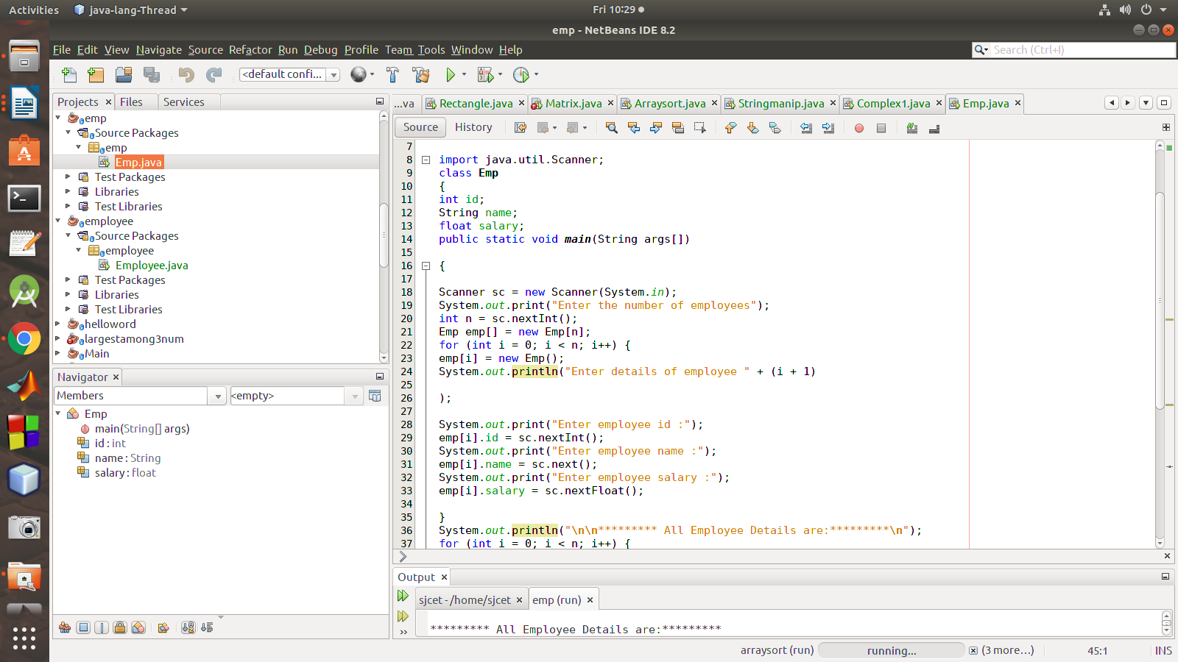

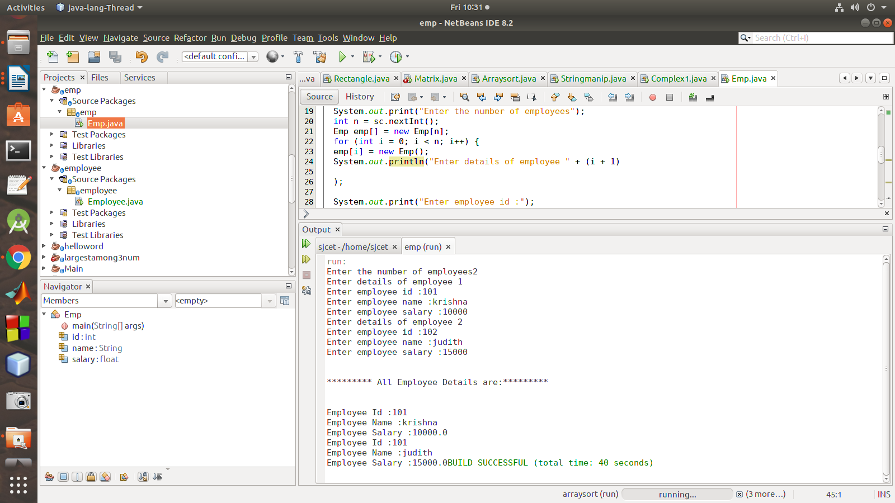

**C03**

**Course Outcome 3(CO3):**

1. Area of different shapes using overloaded functions.

Program:

package areaoverload;

import java.util.Scanner;

/**

*

* @author sjcet

*/

public class AreaOverload {

void area(int x)

{

System.out.println("area of the square:"+(x*x));

}

void area(int x,int y)

{

System.out.println("area of the circle:"+(x*x*3.14));

}

void area(int x,int y,int z)

{

double s= x+y+z/2;

double triarea;

triarea=Math.sqrt(s*(s-x)*(s-y)*(s-z));

System.out.println("area of the triangle is:"+triarea);

}

public static void main(String[] args) {

AreaOverload obj = new AreaOverload ();

Scanner s=new Scanner(System.in);

System.out.println("ENTER SIDE OF SQUARE");

int side=s.nextInt();

System.out.println("ENTER RADIUS OF CIRCLE");

int radius=s.nextInt();

System.out.println("enter side of triangles");

int side1=s.nextInt();

int side2=s.nextInt();

int side3=s.nextInt();

obj.area(side);

obj.area(radius);

obj.area(side1,side2,side3);

}

}

output:

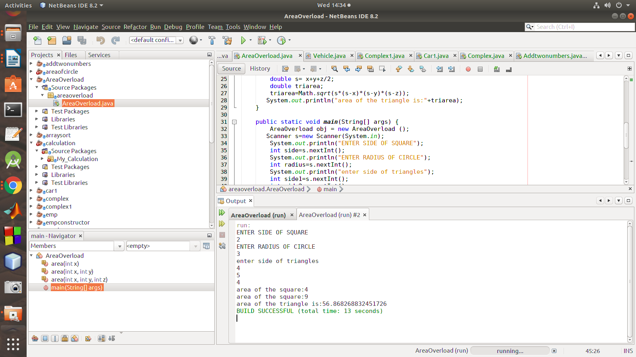

2. Create a class ‘Person’ with data members Name, Gender, Address, Age and a

constructor to initialize the data members and another class ‘Employee’ that inherits

the properties of class Person and also contains its own data members like Empid,

Company_name, Qualification, Salary and its own constructor. Create another class

‘Teacher’ that inherits the properties of class Employee and contains its own data

members like Subject, Department, Teacherid and contain constructors and methods

to display the data members. Use array of objects to display details of N teachers.

Program:

package inheritencepersonexample;

/**

*

* @author sjcet

*/

import java.util.Scanner;

class Person {

String Name, Gender , Address ;

protected int Age ;

public Person ( ) { }

public Person ( String n , String g , String addr , int a ){

this . Name = n ;

this . Gender = g ;

this . Address =addr ;

this . Age = a ;

}

public void displayPerson ( ) {

System.out.println ( "Name: "+Name ) ;

System.out.println ( "Gender : " + Gender ) ;

System.out.println ( " Address : " + Address ) ;

System.out.println ( "Age : " + Age ) ;

}

}

class Employee extends Person {

int Empid , Salary ;

String Companyname , Qualification ;

public Employee ( ) { }

public Employee ( String n , String g , String addr , int a , int eid , String cname , String qual , int sal

){

super ( n , g , addr , a ) ;

Empid = eid ;

Companyname = cname ;

Qualification= qual ;

Salary = sal ;

}

public void displayEmployee ( ) {

super . displayPerson ( ) ;

System.out.println ( "Empid : "+Empid ) ;

System.out.println ( "Company name : " + Companyname ) ;

System.out.println( " Qualification : " + Qualification ) ;

System.out.println ( " Salary : " + Salary ) ;

}

}

class Teacher1 extends Employee{

String Subject , Department ;

int Teacherid ;

public Teacher1 ( String n , String g , String addr , int a ,

int eid , String cname , String qual , int sal ,

String sub , String dept , int tid ){

super ( n , g , addr , a , eid , cname , qual , sal ) ;

Subject = sub ;

Department = dept ;

Teacherid = tid ;

}

public void displayTeacher ( ) {

super . displayEmployee ( ) ;

System.out.println( "Teacherid : " + Teacherid ) ;

System.out.println( "Subject : " + Subject ) ;

System.out.println( "Department : " + Department ) ;

}

}

public class InheritencePersonExample {

public static void main ( String args[ ] ) {

System.out.println( "Enter number of teachers " ) ;

Scanner sc=new Scanner(System.in);

int N = sc . nextInt ( ) ;

Teacher1[ ] teacher1s = new Teacher1 [N ] ;

Scanner scs = new Scanner ( System.in ) ;

for ( int i = 0 ; i<N; i ++){

System.out.println( "Enter name of the teacher " ) ;

String name = scs . nextLine ( ) ;

System.out.println ( "Enter gender of the teacher " ) ;

String gen = scs.next ( ) ;

System.out.println ( "Enter address of the teacher ") ;

String addr = scs.next( ) ;

System.out.println( "Enter age of the teacher " ) ;

int ag = sc.nextInt( ) ;

System.out.println( "Enter Empid o f the teacher ") ;

int eid = sc. nextInt( ) ;

System.out.println ( " Enter Company name " ) ;

String cn = scs.next ( ) ;

System.out.println ( "Enter qualification of the teacher " ) ;

String quali = scs . next ( ) ;

System.out.println ( "Enter salary of the teacher " ) ;

int sal = sc.nextInt( ) ;

System.out.println( " Enter Teacher id " ) ;

int tid =

Scanner sc=new Scanner(System.in);

int N = sc . nextInt ( ) ;

Teacher1[ ] teacher1s = new Teacher1 [N ] ;

Scanner scs = new Scanner ( System.in ) ;

for ( int i = 0 ; i<N; i ++){sc.nextInt( ) ;

System.out.println ( " Enter Subject of the teacher " ) ;

String sub = scs.next ( ) ;

System.out.println ( " Enter Department of the teacher " ) ;

String dept = scs.next( ) ;

Teacher1 t = new Teacher1 ( name , gen , addr , ag , eid , cn , quali , sal , sub , dept , tid ) ;

teacher1s[ i ]=t ;

}

for(Teacher1 t : teacher1s ) {

t . displayTeacher( ) ;

}

}

}

output:

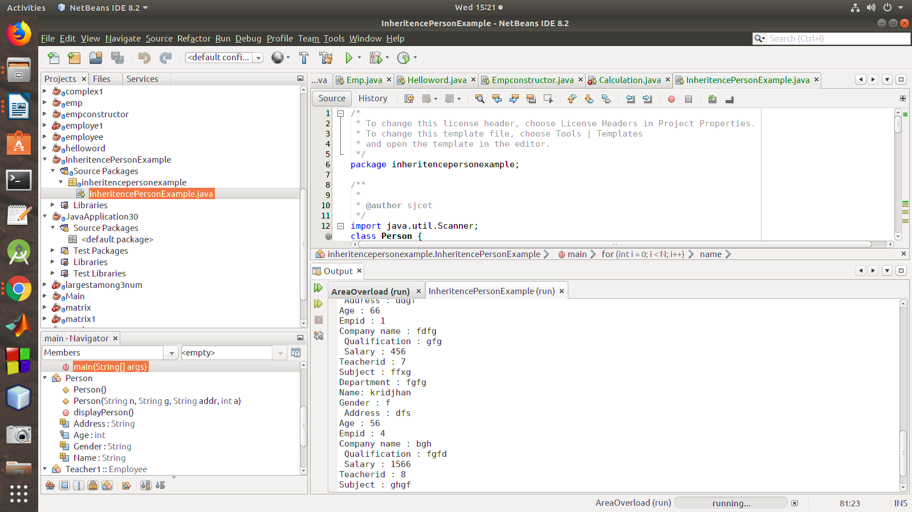

**C04**

**Course Outcome 4 (CO4):**

1)Create a Graphics package that has classes and interfaces for figures Rectangle, Triangle,

Square and Circle. Test the package by finding the area of these figures.

Graphicsque ->projectname

graphics->package

class:-

circle

rectangle

triangle

square

area->package

class:-

area

**circle.java**

package graphics;

/**

*

* @author sjcet

*/

import java.util.Scanner;

public class circle {

public void cirarea(){

Scanner obj=new Scanner(System.in);

System.out.println("enter radius of circle");

int r=obj.nextInt();

double res4=r*r*Math.PI;

System.out.println("area of circle:"+res4);

}

}

**rectangle.java**

package graphics;

/**

*

* @author sjcet

*/

import java.util.Scanner;

public class rectangle {

public void recarea(){

Scanner obj=new Scanner(System.in);

rectangle obj1=new rectangle();

System.out.println("enter length of rectangle");

int len=obj.nextInt();

System.out.println("enter breadth of rectangle");

int br=obj.nextInt();

int res1=len*br;

System.out.println("area od rectangle:"+res1);

}

}

**square.java**

package graphics;

/**

*

* @author sjcet

*/

import java.util.Scanner;

public class square {

public void sqarea(){

Scanner obj=new Scanner(System.in);

System.out.println("enter length of side of square");

int side=obj.nextInt();

int res3=side*side;

System.out.println("area of square:"+res3);

}

}

**triangle.java**

package graphics;

/**

*

* @author sjcet

*/

import java.util.Scanner;

public class triangle {

public void triarea(){

Scanner obj=new Scanner(System.in);

System.out.println("enter length of base of triangle");

int base=obj.nextInt();

System.out.println("enter height of triangle");

int hi=obj.nextInt();

int res2=(base*hi)/2;

System.out.println("area of triangle:"+res2);

}

}

**area.java**

package area;

/**

*

* @author sjcet

*/

import graphics.*;

import java.util.Scanner;

class area {

public static void main(String args[]){

rectangle obj1=new rectangle();

obj1.recarea();

triangle obj2=new triangle();

obj2.triarea();

square obj3=new square();

obj3.sqarea();

circle obj4=new circle();

obj4.cirarea();

}

}

output:

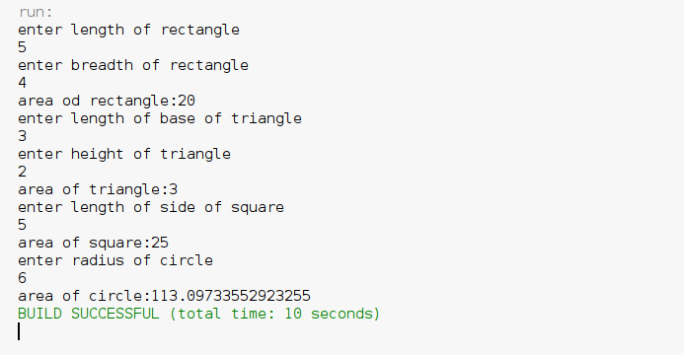

2)Write a user defined exception class to authenticate the user name and password.

package checklogincredential;

/**

*

* @author sjcet

*/

import java.util.Scanner;

class UsernameException extends Exception {

public UsernameException(String msg)

{

super(msg);

}

}

class PasswordException extends Exception {

public PasswordException(String msg)

{

super(msg);

}

}

public class Checklogincredential

{

public static void main(String[] args) {

Scanner s = new Scanner(System.in);

String username, password;

System.out.print("Enter username :: ");

username = s.nextLine();

System.out.print("Enter password :: ");

password = s.nextLine();

int length = username.length();

try

{

if(!username.equals("admin"))

throw new UsernameException("Username must be admin");

else if(!password.equals("admin"))

throw new PasswordException("Incorrect password\nType correct password ???");

else

System.out.println("Login Successful !!!");

}

catch (UsernameException u)

{

u.printStackTrace();

}

catch (PasswordException p)

{

p.printStackTrace();

}

finally

{

System.out.println("The finally statement is executed");

}

}

}

**C05**

**AwtbiggestCourse Outcome 5 (CO5):**

1.Program to find a maximum of three numbers using AWT.

package awtbiggest;

import java.awt.*;

import java.awt.event.*;

public class Awtbiggest implements ActionListener{

Frame f=new Frame();

Label l1=new Label("First Number");

Label l2=new Label("Second Number");

Label l3=new Label("Third Number");

Label l4=new Label("Largest Number");

TextField t1=new TextField();

TextField t2=new TextField();

TextField t3=new TextField();

TextField t4=new TextField();

Button b1=new Button("find");

Button b2=new Button("Cancel");

Awtbiggest()

{

l1.setBounds(50,100,100,20);

l2.setBounds(50,140,100,20);

l3.setBounds(50,180,100,20);

l4.setBounds(50,220,100,20);

t1.setBounds(200,100,100,20);

t2.setBounds(200,140,100,20);

t3.setBounds(200,180,100,20);

t4.setBounds(200,220,100,20);

b1.setBounds(50,250,50,20);

b2.setBounds(110,250,50,20);

f.add(l1);

f.add(l2);

f.add(l3);

f.add(l4);

f.add(t1);

f.add(t2);

f.add(t3);

f.add(t4);

f.add(b1);

f.add(b2);

b1.addActionListener(this);

b2.addActionListener(this);

f.setLayout(null);

f.setVisible(true);

f.setSize(400,350);

}

public void actionPerformed(ActionEvent e)

{

int n1=Integer.parseInt(t1.getText());

int n2=Integer.parseInt(t2.getText());

int n3=Integer.parseInt(t3.getText());

if(e.getSource()==b1)

{

if(n1>n2){

if(n1>n3){

t4.setText(String.valueOf(n1));

}

}

else if(n2>n3){

t4.setText(String.valueOf(n2));

}

else{

t4.setText(String.valueOf(n3));

}

}

if(e.getSource()==b2)

{

System.exit(0);

}

}

public static void main(String[] args) {

new Awtbiggest();

}

}

output:

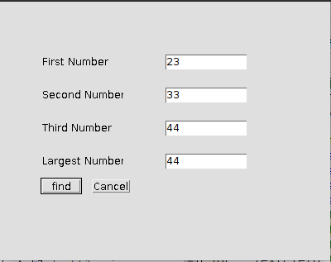

**simple interest**

package simpleinterest;

import java.awt.*;

import java.awt.event.*;

/**

*

* @author sjcet

*/

public class Simpleinterest implements ActionListener{

Frame f=new Frame();

Label l1=new Label("Principle");

Label l2=new Label("Number of years");

Label l3=new Label ("Rate");

Label l4=new Label("simpleinterest");

TextField t1= new TextField();

TextField t2=new TextField();

TextField t3=new TextField();

TextField t4=new TextField();

Button b1= new Button("calculate");

Simpleinterest()

{

l1.setBounds(50, 100, 100, 20);

l2.setBounds(50, 140, 100, 20);

l3.setBounds(50, 180, 100, 20);

l4.setBounds(50, 220, 100, 20);

t1.setBounds(200,100 , 100, 20);

t2.setBounds(200, 140, 100, 20);

t3.setBounds(200, 180, 100, 20);

t4.setBounds(200, 220, 100, 20);

b1.setBounds(50, 250, 50, 20);

f.add(l1);

f.add(l2);

f.add(l3);

f.add(l4);

f.add(t1);

f.add(t2);

f.add(t3);

f.add(t4);

f.add(b1);

b1.addActionListener(this);

f.setLayout(null);

f.setVisible(true);

f.setSize(600, 600);

}

public void actionPerformed(ActionEvent e)

{

int n1=Integer.parseInt(t1.getText());

int n2=Integer.parseInt(t2.getText());

int n3=Integer.parseInt(t3.getText());

if(e.getSource()==b1)

{

t4.setText(String.valueOf((n1*n2*n3)/100));

}

}

public static void main(String args[])

{

new Simpleinterest();

}

**Output**

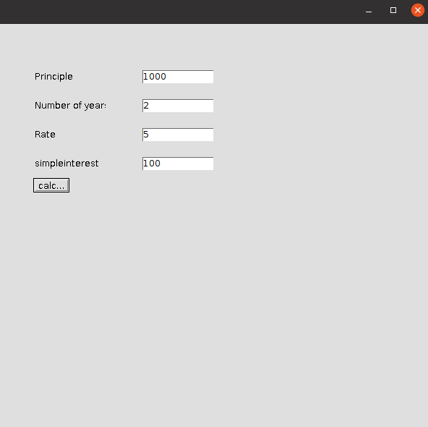

2.Implement a simple calculator using AWT components.

package awtcalculator;

/**

*

* @author sjcet

*/

import java.awt.*;

import java.awt.event.*;

class Awtcalculator implements ActionListener {

//Declaring Objects

Frame f=new Frame();

Label l1=new Label("First Number");

Label l2=new Label("Second Number");

Label l3=new Label("Result");

TextField t1=new TextField();

TextField t2=new TextField();

TextField t3=new TextField();

Button b1=new Button("Add");

Button b2=new Button("Sub");

Button b3=new Button("Mul");

Button b4=new Button("Div");

Button b5=new Button("Cancel");

Awtcalculator()

{

l1.setBounds(50,100,100,20);

l2.setBounds(50,140,100,20);

l3.setBounds(50,180,100,20);

t1.setBounds(200,100,100,20);

t2.setBounds(200,140,100,20);

t3.setBounds(200,180,100,20);

b1.setBounds(50,250,50,20);

b2.setBounds(110,250,50,20);

b3.setBounds(170,250,50,20);

b4.setBounds(230,250,50,20);

b5.setBounds(290,250,50,20);

f.add(l1);

f.add(l2);

f.add(l3);

f.add(t1);

f.add(t2);

f.add(t3);

f.add(b1);

f.add(b2);

f.add(b3);

f.add(b4);

f.add(b5);

b1.addActionListener(this);

b2.addActionListener(this);

b3.addActionListener(this);

b4.addActionListener(this);

b5.addActionListener(this);

f.setLayout(null);

f.setVisible(true);

f.setSize(400,350);

}

public void actionPerformed(ActionEvent e)

{

int n1=Integer.parseInt(t1.getText());

int n2=Integer.parseInt(t2.getText());

if(e.getSource()==b1)

{

t3.setText(String.valueOf(n1+n2));

}

if(e.getSource()==b2)

{

t3.setText(String.valueOf(n1-n2));

}

if(e.getSource()==b3)

{

t3.setText(String.valueOf(n1*n2));

}

if(e.getSource()==b4)

{

t3.setText(String.valueOf(n1/n2));

}

if(e.getSource()==b5)

{

System.exit(0);

}

}

public static void main(String[] args) {

new Awtcalculator();

}

}

output:

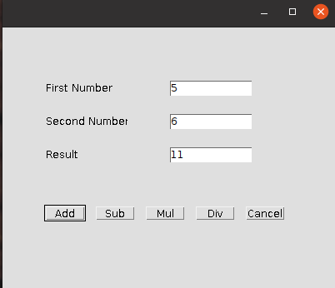

3. Develop  a program to handle all mouse events and window events

package mouseevents;

/**

*

* @author sjcet

*/

import java.awt.*;

import java.awt.event.*;

public class Mouseevents extends Frame implements MouseListener {

Label l;

Mouseevents(){

addMouseListener(this);

l=new Label();

l.setBounds(20,50,100,20);

add(l);

setSize(300,300);

setLayout(null);

setVisible(true);

}

public void mouseClicked(MouseEvent e) {

l.setText("Mouse Clicked");

}

public void mouseEntered(MouseEvent e) {

l.setText("Mouse Entered");

}

public void mouseExited(MouseEvent e) {

l.setText("Mouse Exited");

}

public void mousePressed(MouseEvent e) {

l.setText("Mouse Pressed");

}

public void mouseReleased(MouseEvent e) {

l.setText("Mouse Released voi");

}

public static void main(String[] args) {

new Mouseevents();

}

}

output:

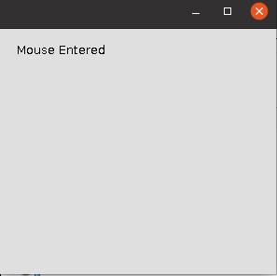

4. Develop a program to handle Key events.

package keyevents;

/**

* @author sjcet

*/

import java.awt.*;

import java.awt.event.*;

public class Keyevents extends Frame implements KeyListener {

Label l;

TextArea area;

Keyevents() {

l = new Label();

l.setBounds (20, 50, 100, 20);

area = new TextArea();

area.setBounds (20, 80, 300, 300);

area.addKeyListener(this);

add(l);

add(area);

setSize (400, 400);

setLayout (null);

setVisible (true);

}

public void keyPressed (KeyEvent e) {

l.setText ("Key Pressed");

}

public void keyReleased (KeyEvent e) {

l.setText ("Key Released");

}

public void keyTyped (KeyEvent e) {

l.setText ("Key Typed"); class MyException extends Exception

{

public MyException(String str)

{

System.out.println(str);

}

}class MyException extends Exception

{

public MyException(String str)

{

System.out.println(str);

}

}class MyException extends Exception

{

public MyException(String str)

{

System.out.println(str);

}

}

}

public static void main(String[] args)

{

new Keyevents();

}

output:

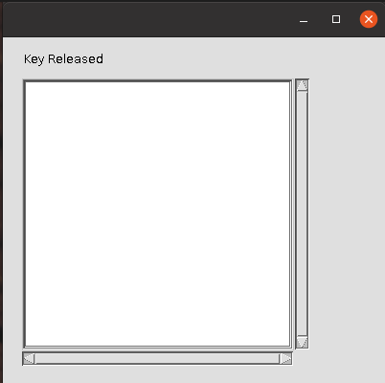

**CO6**

**Course Outcome 6 (CO6):**

1)Write a program to write to a file, then read from the file and display the contents on the console.

package filewrt;

/**

*

* @author sjcet

*/

import java.io.FileWriter;

import java.io.IOException;

import java.io.File;

import java.io.FileNotFoundException;

import java.util.Scanner;

public class Filewrt {

public static void main(String[] args) {

try{

FileWriter dataWriter=new FileWriter("DATA.txt");

dataWriter.write("Hai Hallo");

dataWriter.write("World");

dataWriter.close();

}catch(IOException ex){

System.out.println("An error occured!");

ex.printStackTrace();

}

try{

File dataFile=new File("DATA.txt");

Scanner dataRead= new Scanner(dataFile);

while(dataRead.hasNextLine()){

System.out.println(dataRead.nextLine());

}

dataRead.close();

}catch(FileNotFoundException ex){

System.out.println("An error occured!");

ex.printStackTrace();

}

}

}

OUTPUT:

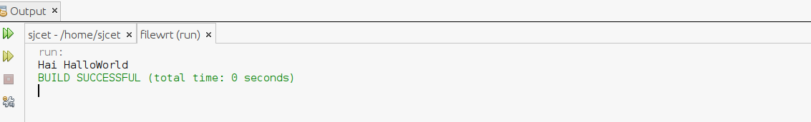

2)Write a program that reads from a file having integers. Copy even numbers and odd

numbers to separate files

package fileoddeven;

/**

*

* @author sjcet

*/

import java.io.File;

import java.io.FileWriter;

import java.io.IOException;

import java.util.Scanner;

public class Fileoddeven {

static String data ="";

static File dataFile=new File("example.txt");

public static void main(String[] args) {

try

{

FileWriter oddFile=new FileWriter("odd.txt");

FileWriter evenFile =new FileWriter("even.txt");

Scanner dataRead =new Scanner(dataFile);

while(dataRead.hasNextLine()){

data+=dataRead.nextLine();

}

dataRead.close();

String values[]=data.split("");

int valuesInt[]=new int[values.length+1];

int count =0;

for(String i:values){

valuesInt[count++]=Integer.parseInt(i);

if(Integer.parseInt(i)%2==0){

evenFile.write(i+"");

}else{

oddFile.write(i+"");

}

}

oddFile.close();

evenFile.close();

}catch(IOException ex){

System.out.println("an error occured");

System.out.println(ex.getMessage());

}

}

}

output:

example.txt: 1 2 3 4 5 6 7 8 9

even number:2 4 6 8

odd number:1 3 5 7 9

